Experiment 3

Aim: Implement Predictive Parser for the given grammar.

Code:
import java.util.*;

public class preparser{
static char[] stack = new char[20];
static int top;
static ArrayList<Table> prods = new ArrayList<Table>();

public static void main(String[] args){
top = -1;
prods.add(new Table('A','a',"aX"));
prods.add(new Table('X','b',"BBX"));
prods.add(new Table('X','d',"BBX"));
prods.add(new Table('X','$',"^"));
prods.add(new Table('B','b',"bY"));
prods.add(new Table('B','d',"dY"));
prods.add(new Table('Y','b',"^"));
prods.add(new Table('Y','c',"CY"));
prods.add(new Table('Y','d',"^"));
prods.add(new Table('Y','$',"^"));
prods.add(new Table('C','c',"c"));

Scanner sc = new Scanner(System.in);
System.out.println("Enter the input to be checked");
String input = sc.next();

push('$');
push('A');

for(int i = 0; i < input.length();){
char tsym = stack[top];
boolean found = false;

if(stack[top] == '$' && input.charAt(i) == '$'){
System.out.println("String is derivable");
break;
}

if(stack[top] == '^'){
pop();
continue;
}

for(int j = 0 ; j < prods.size(); j++){
Table x = prods.get(j);
if(x.getCol() == input.charAt(i) && x.getRow() == tsym){
found = true;
String result = x.getProd();
pop();
for(int k = result.length() - 1; k >= 0; k--){
push(result.charAt(k));
}
}
}

if(!found){
System.out.println("String is not derivable");
break;
}

if(stack[top] == input.charAt(i)){
i++;
pop();
}

}

}

static void pop(){
top--;
}

static void push(char x){
stack[++top] = x;
}
}

class Table{
char row;
char col;
String prod;

Table(char row, char col, String result){
this.row = row;
this.col = col;
prod = result;
}

public char getRow(){
return row;
}

public char getCol(){
return col;
}

public String getProd(){
return prod;
}
}

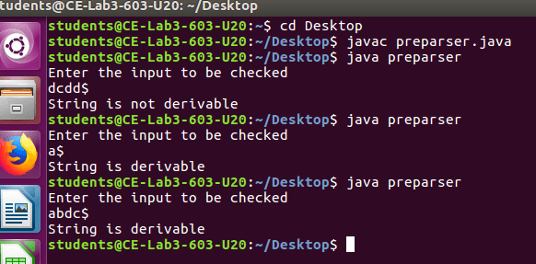
Output:

Conclusion:
Hence, we have understood a predictive parser and successfully implemented it in Java.

